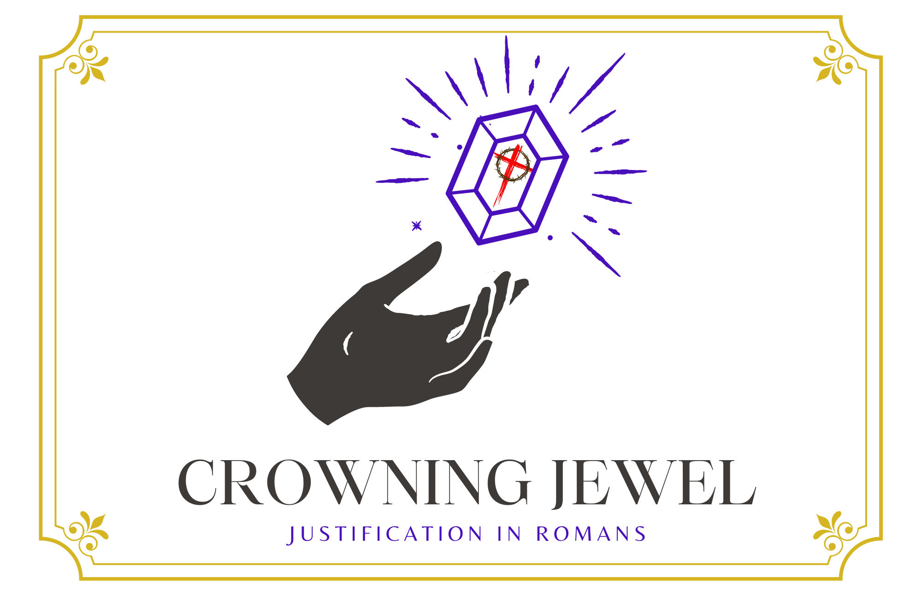

1st Sunday in Lent
CHRIST LUTHERAN CHURCH | Lodi, California
February 18, 2024

WELCOME TO WORSHIP
Welcome to Christ Lutheran Church. We pray that your soul will be strengthened by the good news about God’s grace, love, and forgiveness given to us. If you would like to learn more about our church, please speak with our pastor or one of our members after the service.
- Bathrooms are located in the fellowship hall. A changing table is located in the women’s bathroom.
WORSHIP THEME
Christ is our defense. Through his victory over Satan in the wilderness, Jesus demonstrates that our salvation is sure: the accusations and temptations of the devil cannot harm us. In fact, there is nothing in all creation that can separate us from the love of God.
One theologian has called justification the crowning jewel of Christian doctrine. Like a finely cut gemstone, this teaching of the Bible has many facets, and every time we examine it from a different angle, new truths and fresh insights come into view like light reflecting from its face. During the season of Lent, we will examine some of the various aspects of what Christ accomplished for us.
The Service of the Word and Sacrament
The high and holy worship of God is faith in Jesus Christ. Such faith is created and sustained by God’s service to us (the German, “Gottesdienst,” “God/Divine Service). In the Divine Service, the Lord comes to us in His Word and Sacrament to bless and enliven us with His gifts. The Service is not something we do for God, but His service to us received in faith. The liturgy is God’s work. He gives, we receive.
HYMN I Walk in Danger All the Way| CW 431

INVOCATION
From God’s Word we know that wherever God puts His name, there He is to bless. In the Old Testament the temple was the place where God graciously caused His name to be present (1 Kings 8:27-30).
God has put His name —Father, Son, and Holy Spirit—on us in Holy Baptism. The Divine Service begins with the Invocation, the words spoken over us at our baptisms. Every Divine Service is for the hallowing of the Lord’s name, which the Small Catechism reminds us is done “when the Word of God is taught in its truth and purity, and we, as the children of God, also lead holy lives according to it” (Matthew 28:18-20).
M: The grace of our Lord ✙ Jesus Christ and the love of God and the fellowship of the Holy Spirit be with you.
C: And also with you.
CONFESSION
M: God invites us to come into his presence and worship him with humble and penitent hearts. Therefore, let us acknowledge our sinfulness and ask him to forgive us.
C: Holy and merciful Father, I confess that I am by nature sinful, and that I have disobeyed you in my thoughts, words, and actions. I have done what is evil and failed to do what is good. For this I deserve your punishment both now and in eternity. But I am truly sorry for my sins, and trusting in my Savior Jesus Christ, I pray: Lord, have mercy on me, a sinner.

absolution
M: God, our heavenly Father, has been merciful to us and has given his only Son to be the atoning sacrifice for our sins. Therefore, as a called servant of Christ and by his authority, I forgive you all your sins in the name of the Father and of the Son ✙ and of the Holy Spirit.
C: Amen
LORD, HAVE MERCY - Kyrie
M: For all that we need in life and for the wisdom to use all your gifts with gratitude and joy, hear our prayer, O Lord.
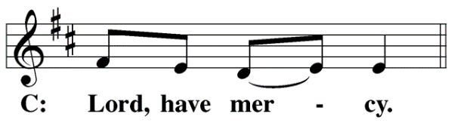

M: For the steadfast assurance that nothing can separate us from your love and for the courage to stand firm against the assaults of Satan and every evil, hear our prayer, O Christ.
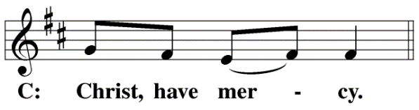
M: For the well-being of your holy Church in all the world and for those who offer here their worship and praise, hear our prayer, O Lord.
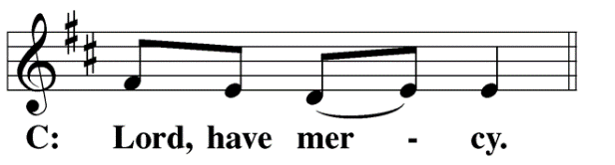
M: Merciful God, maker and preserver of life, uphold us by your power and keep us in your tender care:
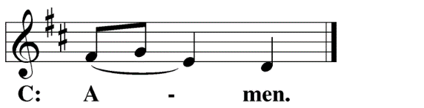
The Service of the Word
Having just received absolution for their sins, believers now gather around the Word of God to find encouragement and peace for their lives on earth.
PRAYER OF THE DAY
M: Let us pray.
Lord our strength, the battle of good and evil rages within and around us, and our ancient foe tempts us with his deceits and empty promises. Keep us steadfast in your Word, and when we fall, raise us up again and restore us through your Son, Jesus Christ our Lord, who lives and reigns with you and the Holy Spirit, one God, now and forever.
C: Amen

FIRST LESSON Genesis 22:1–18
The real test for Abraham: will God provide?
22 Some time later God tested Abraham. He said to him, “Abraham!”
“Here I am,” he replied.
² Then God said, “Take your son, your only son, whom you love—Isaac—and go to the region of Moriah. Sacrifice him there as a burnt offering on a mountain I will show you.”
³ Early the next morning Abraham got up and loaded his donkey. He took with him two of his servants and his son Isaac. When he had cut enough wood for the burnt offering, he set out for the place God had told him about. ⁴ On the third day Abraham looked up and saw the place in the distance. ⁵ He said to his servants, “Stay here with the donkey while I and the boy go over there. We will worship and then we will come back to you.”
⁶ Abraham took the wood for the burnt offering and placed it on his son Isaac, and he himself carried the fire and the knife. As the two of them went on together, ⁷ Isaac spoke up and said to his father Abraham, “Father?”
“Yes, my son?” Abraham replied.
“The fire and wood are here,” Isaac said, “but where is the lamb for the burnt offering?”
⁸ Abraham answered, “God himself will provide the lamb for the burnt offering, my son.” And the two of them went on together.
⁹ When they reached the place God had told him about, Abraham built an altar there and arranged the wood on it. He bound his son Isaac and laid him on the altar, on top of the wood. ¹⁰ Then he reached out his hand and took the knife to slay his son. ¹¹ But the angel of the Lord called out to him from heaven, “Abraham! Abraham!”
“Here I am,” he replied.
¹² “Do not lay a hand on the boy,” he said. “Do not do anything to him. Now I know that you fear God, because you have not withheld from me your son, your only son.”
¹³ Abraham looked up and there in a thicket he saw a ram caught by its horns. He went over and took the ram and sacrificed it as a burnt offering instead of his son. ¹⁴ So Abraham called that place The Lord Will Provide. And to this day it is said, “On the mountain of the Lord it will be provided.”
¹⁵ The angel of the Lord called to Abraham from heaven a second time ¹⁶ and said, “I swear by myself, declares the Lord, that because you have done this and have not withheld your son, your only son, ¹⁷ I will surely bless you and make your descendants as numerous as the stars in the sky and as the sand on the seashore. Your descendants will take possession of the cities of their enemies, ¹⁸ and through your offspring all nations on earth will be blessed, because you have obeyed me.”

PSALM Psalm 6, Page 66
SECOND LESSON Romans 8:31–39
Christ is our sure defense: nothing can separate us from God’s love or his victory.
³¹ What, then, shall we say in response to these things? If God is for us, who can be against us? ³² He who did not spare his own Son, but gave him up for us all—how will he not also, along with him, graciously give us all things? ³³ Who will bring any charge against those whom God has chosen? It is God who justifies. ³⁴ Who then is the one who condemns? No one. Christ Jesus who died—more than that, who was raised to life—is at the right hand of God and is also interceding for us. ³⁵ Who shall separate us from the love of Christ? Shall trouble or hardship or persecution or famine or nakedness or danger or sword? ³⁶ As it is written:
“For your sake we face death all day long;
we are considered as sheep to be slaughtered.”
³⁷ No, in all these things we are more than conquerors through him who loved us. ³⁸ For I am convinced that neither death nor life, neither angels nor demons, neither the present nor the future, nor any powers, ³⁹ neither height nor depth, nor anything else in all creation, will be able to separate us from the love of God that is in Christ Jesus our Lord.
VERSE OF THE DAY Matthew 4:23
Alleluia. Jesus went throughout Galilee, teaching, preaching, and healing every disease. Alleluia.
THE GOSPEL Mark 1:12–15
Christ defeats the devil, conquering temptation for us.
¹² At once the Spirit sent him out into the wilderness, ¹³ and he was in the wilderness forty days, being tempted by Satan. He was with the wild animals, and angels attended him.
¹⁴ After John was put in prison, Jesus went into Galilee, proclaiming the good news of God. ¹⁵ “The time has come,” he said. “The kingdom of God has come near. Repent and believe the good news!”
HYMN OF THE DAY Dear Christians, One and All Rejoice| CW 377 v 1–7
SERMON 1 Kings 19

NICENE CREED
Having heard the Word of God, we confess our faith in His name. The creed is our saying back to God what He has first said to us. In the Creed we acclaim the truth of the triune God and His work of salvation accomplished for us in His incarnate Son, Jesus Christ.
We believe in one God, Dt. 6:4
the Father, the Almighty, 2 Cor. 6:18
maker of heaven and earth, Is. 51:13
The Nicene Creed is the great Confession of the Christian faith professed by all Christians. The Creed originated at the First Council of Nicaea (c. AD. 325)
of all that is, seen and unseen. Col. 1:16
We believe in one Lord, Jesus Christ, 1 Cor 8:6
the only Son of God, Jn. 3:16
eternally begotten of the Father, Heb. 1:2,5
God from God, Light from Light, true God from true God, Jn. 1
begotten, not made, of one being with the Father. Jn. 10:30
Through him all things were made. Jn. 1:3
For us and for our salvation, 1 Th. 5:9
he came down from heaven, Jn. 6:38
was incarnate of the Holy Spirit and the virgin Mary, Lk. 1:35
The Creed itself was crafted as a confession of Scripture in opposition to the Arian heresy, which denied that the Lord Jesus and the Holy Spirit are God.

and became fully human. Gal. 4:4
For our sake he was crucified under Pontius Pilate. Mk. 15:15
He suffered death and was buried. 1 Cor. 15:3-4a
On the third day he rose again in accordance
with the Scriptures. 1 Cor. 15:4b
He ascended into heaven Ac. 2:33-34
and is seated at the right hand of the Father. Heb. 1:13
He will come again in glory Mt. 25:31
to judge the living and the dead, 2 Tim. 4:1
and his kingdom will have no end. Lk. 1:33
We believe in the Holy Spirit, the Lord, the giver of life, Job 33:4
who proceeds from the Father and the Son, Jn. 15:26
who in unity with the Father and the Son Jn. 4:24
is worshiped and glorified,
who has spoken through the prophets. 2 Pet. 1:25
We believe in one holy Christian Mt. 16:18; Eph. 2:19-20
and apostolic Church.
We acknowledge one baptism for the forgiveness of sins. Eph. 4:5; Ac. 2:38
We look for the resurrection of the dead 1 Cor. 15:21-22
and the life of the world to come. Amen. Rev. 22
OFFERING
In response to God’s love and forgiveness, we give back a portion of what he has given us. The members of Christ Lutheran Church have joined to proclaim the gospel to this community. These offerings support that work. While our guests are welcome to participate, they should not feel obligated to do so.
PRAYER OF THE CHURCH
M: Heavenly Father, you loved the world and gave your Son to liberate us from sin and death by his obedient death on the cross.
C: We confess that without your love we are lost.
M: Lord of the Church, we thank you for the treasure of the gospel. By your Spirit, keep our eyes fixed on Jesus, the author and perfecter of our faith.
C: Strengthen us to do what pleases you, no matter the cost.
M: We pray for those who carry a cross in the name of Christ: all who face ridicule because they bear your Name, those who suffer persecution under oppressive governments, missionaries that are far from the familiar, chaplains who bear the griefs and sorrows of those under their care, young people who stand up for what is right in the face of pressure, and all others who pay an earthly price to follow your Son.
C: Give them your Holy Spirit and a rich measure of patience and endurance.
M: We pray for those who carry heavy burdens: the sick and the chronically ill, the depressed and lonely, the mourning and the dying, those torn by conflict in their families, those who live under the threat of war, and all who face life’s terrors with a heavy heart.
C: Have mercy upon them and grant them peace, hope, and comfort, O Lord.
M: We pray for those who care for others: pastors and counselors; doctors and nurses; social workers and caring friends; all who feed the hungry, comfort the hurting, and stand beside the dying.
C: Strengthen them in their work, O Lord; do not let them become weary in doing good.
M: We pray for our nation and our leaders. Grant wisdom to our president, to the members of our nation’s congress and the judges who preside over the Supreme Court. Be with leaders at every level of national, state, and local government. Move the leaders and the people of our land to repentance.
C: May all people turn to you for eternal salvation and guidance through this life.
M: Help us run with perseverance the race marked out for us. Keep us faithful even to the point of death, that we may receive the crown of life; through Jesus Christ, our Lord.
C: Amen.
LORD’S PRAYER Matthew 6:9-13; Luke 11:2-4
C: Our Father, who art in heaven, hallowed be thy name,
thy kingdom come, thy will be done
on earth as it is in heaven.
Give us this day our daily bread;
and forgive us our trespasses, as we forgive those
who trespass against us;
and lead us not into temptation, but deliver us from evil.
For thine is the kingdom and the power
and the glory forever and ever. Amen.
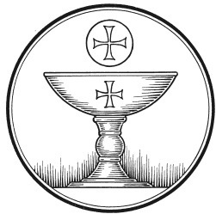

The Service of the Sacrament
This greeting marks a new service, so to speak. These ancient introductory words & phrases help to highlight, celebrate and bring attention to the Sacrament.
M: The Lord be with you.
C: And also with you.
M: Lift up your hearts.
C: We lift them up to the Lord.
M: Let us give thanks to the Lord our God.
C: It is right to give him thanks and praise.
M: Praise to the God and Father of our Lord Jesus Christ! In love he has blessed us with every spiritual blessing. He gave his Son to be the atoning sacrifice for our sins, and not only for ours but also for the sins of the whole world. Now have come the salvation and the power and the kingdom of our God and the authority of his Christ. To him who sits on the throne and to the Lamb be praise and thanks and honor and glory for ever and ever:

HOLY, HOLY, HOLY – Sanctus
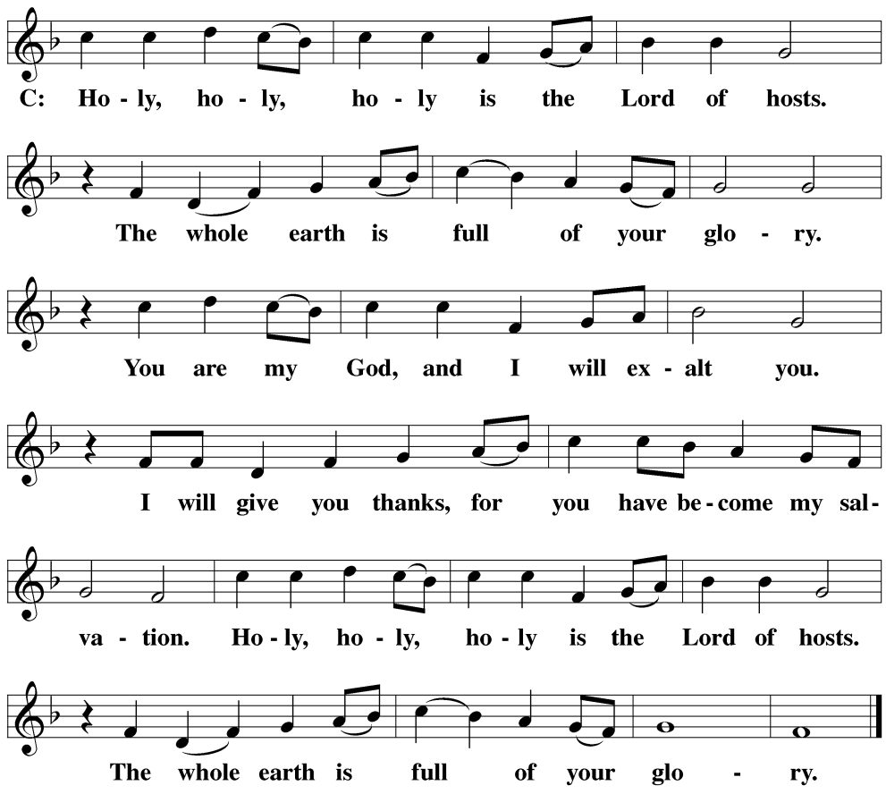
WORDS OF INSTITUTION Matthew 26, Mark 14, Luke 22
M: Our Lord Jesus Christ, on the night he was betrayed, took bread; and when he had given thanks, he broke it and gave it to his disciples, saying: “Take and eat. This is my ✙ body, which is given for you. Do this in remembrance of me.”
The Words of institution both proclaim the words of Jesus to the congregation and sets apart the bread and wine for the Lord’s Supper.
Then he took the cup, gave thanks, and gave it to them, saying, “Drink from it all of you; this is my ✙ blood of the new covenant, which is poured out for you for the forgiveness of sins. Do this, whenever you drink it, in remembrance of me.”
PEACE OF THE LORD – Pax Domini John 20:19
M: The peace of the Lord be with you always.
C: Amen
O CHRIST, LAMB OF GOD – Agnus Dei John 1:29
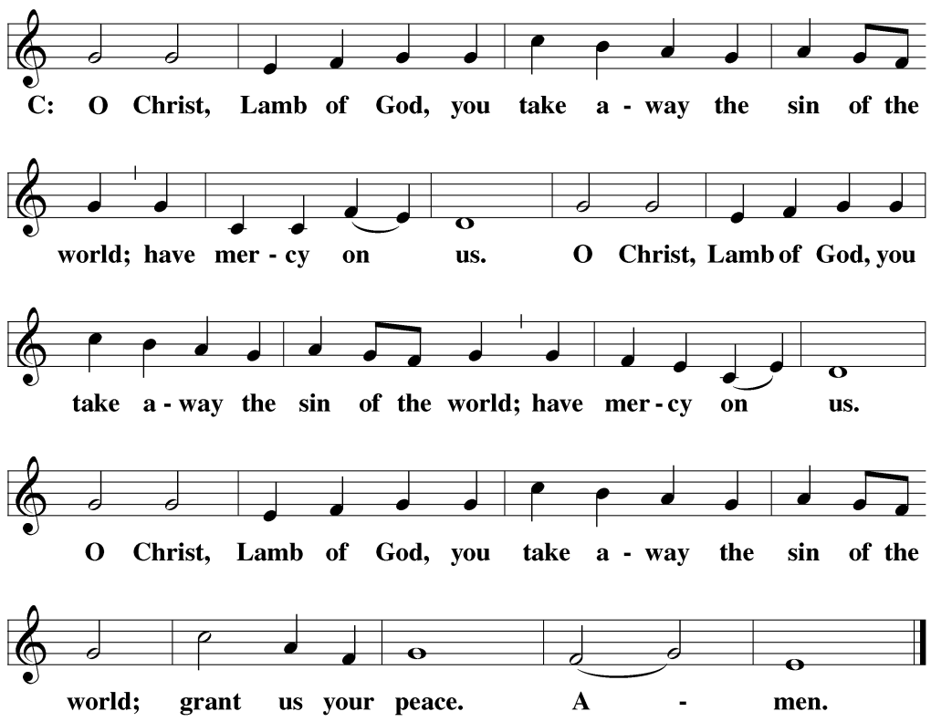
DISTRIBUTION
Those who will be receiving Holy Communion today may wish to read Personal Preparation for Holy Communion, found on page 156 in the front section of the hymnal. This page helps us put into practice what the Bible encourages: “Everyone ought to examine themselves before they eat of the bread and drink from the cup.” (1 Corinthians 11:28)
Christ Lutheran Church confesses and practices the Biblical teaching of a Closed Communion. We ask that only members of the Wisconsin Synod [WELS] or the Evangelical Lutheran Synod [ELS] join us at the Lord’s Table. If you have questions concerning our communion practice, or would like to inquire about how you, too, can commune with us, please speak with the Pastor following the service.
M: Hear the prayer of your people, O Lord, that the lips which have praised you here may glorify you in the world, that the eyes which have seen the coming of your Son may long for his coming again, and that all who have received in his true body and blood the pledge of your forgiveness may be restored to live a new and holy life, through Jesus Christ, our Lord, who lives and reigns with you and the Holy Spirit, one God, now and forever.
C: Amen.
THE BLESSING
M: Brothers and sisters, go in peace. Live in harmony with one another. Serve the Lord with gladness.
The Lord bless you and keep you.
The Lord make his face shine on you and be gracious to you.
The Lord look on you with favor and ✙ give you peace.
C: Amen.
CLOSING HYMN If God Himself Be For Me| CW 419

COPYRIGHT INFORMATION
Content requiring a copyright license is reproduced under OneLicense.net #A-718312. All rights reserved. The Common Service: Texts revised from The Lutheran Hymnal, 1941. Music revised by James Engel. Scripture Quotations: From the Holy Bible, New International Version (NIV 1984), © 1973, 1978, 1984 by Biblica, Inc.

WELCOME TO CHRIST EV. LUTHERAN CHURCH!
We preach a message of forgiveness, hope and peace
through the death and resurrection of Jesus Christ.
Families and individuals of all ages will find opportunities
both to grow and to serve.
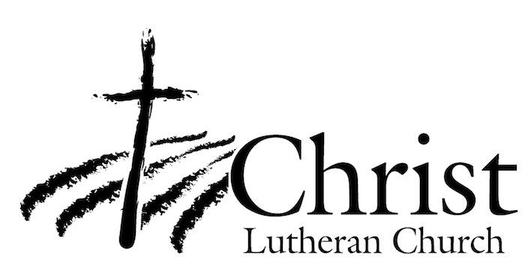
13009 N. Elderberry Ct.
Lodi, CA 95242
www.christlodi.org
209-368-6250
Pastor Tim Leistekow

